**Django Report Builder Documentation for Marked by Covid**

<https://django-report-builder.readthedocs.io/en/latest/howto/>

This report builder allows you to easily export data to an .xlsx file. Reports are pre-built, allowing you to re-use the same report over and over.

Say you want to export all data for all memorials, or all data for some memorials, or some data for some memorials, or some data for all memorials, you can do all of the above. Cool right?

First login to the admin panel.

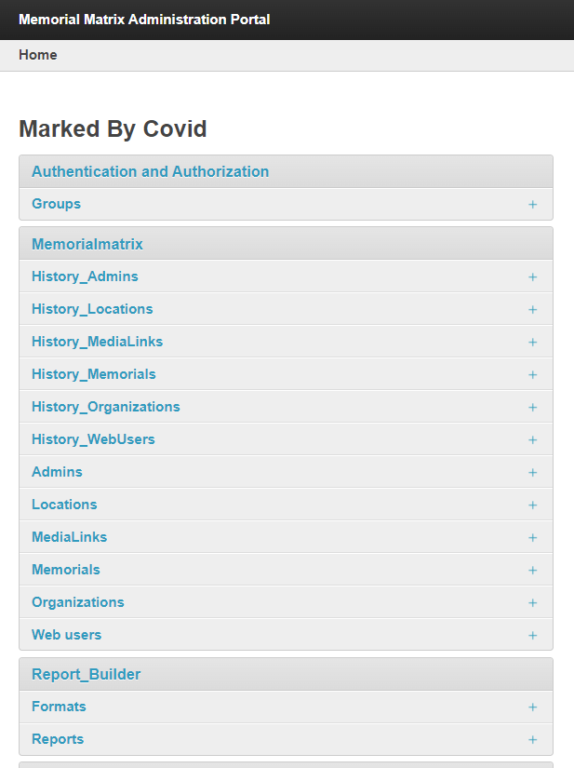

Then select where it says “Reports”

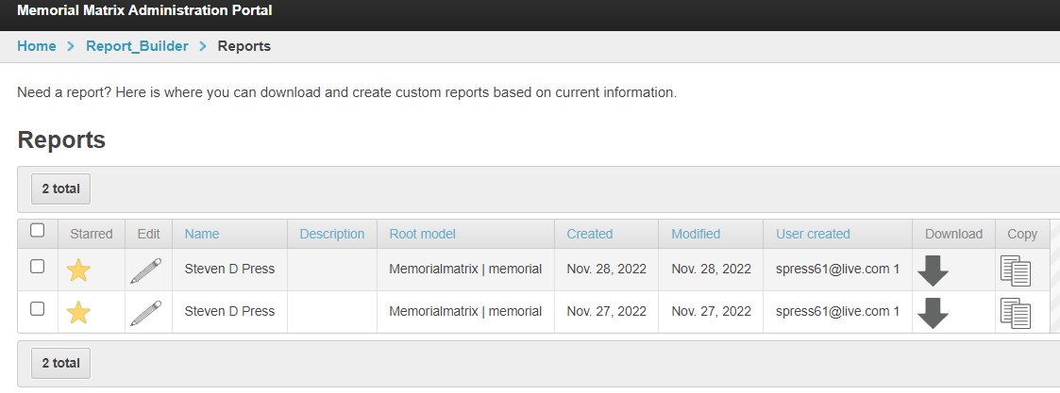

Here you will see all of your previously created reports. You can edit, copy, download, or favorite these reports.

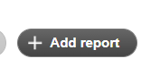

In the top righthand corner select add report

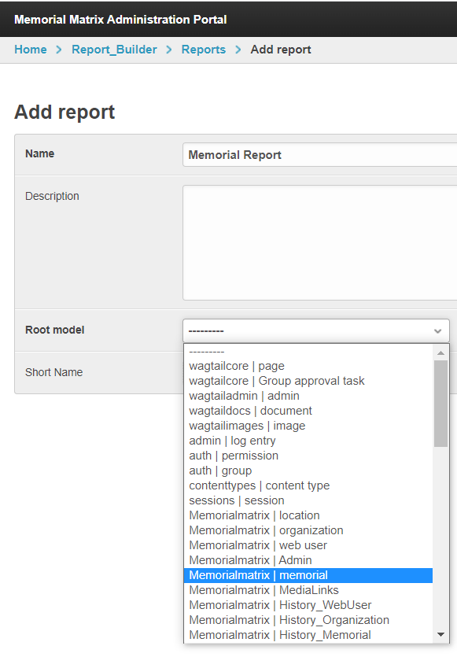

Here you will name your report and select the model for your report. There are many options for selecting a model. It is 99% likely that you will never use any report for wagtail. 95% of the time you will use models starting with Memorialmatrix.

Models starting with “History_” is a model that stores every version of every memorial, location, medialinks, etc. If you export these, it will be a big report.



In the top right-hand corner click the hamburger.

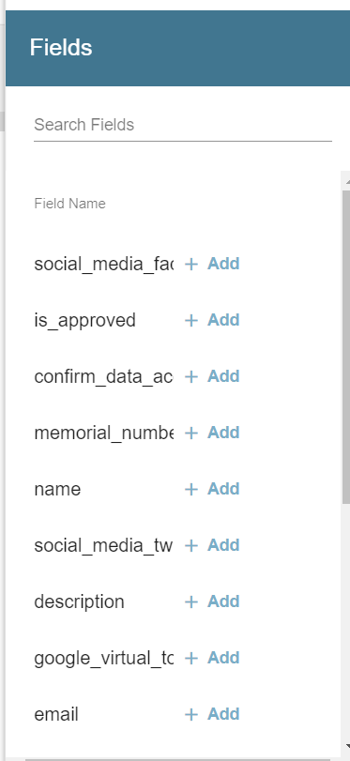

In the sidebar, these are where you can add fields to your report. You can select all fields or some fields.

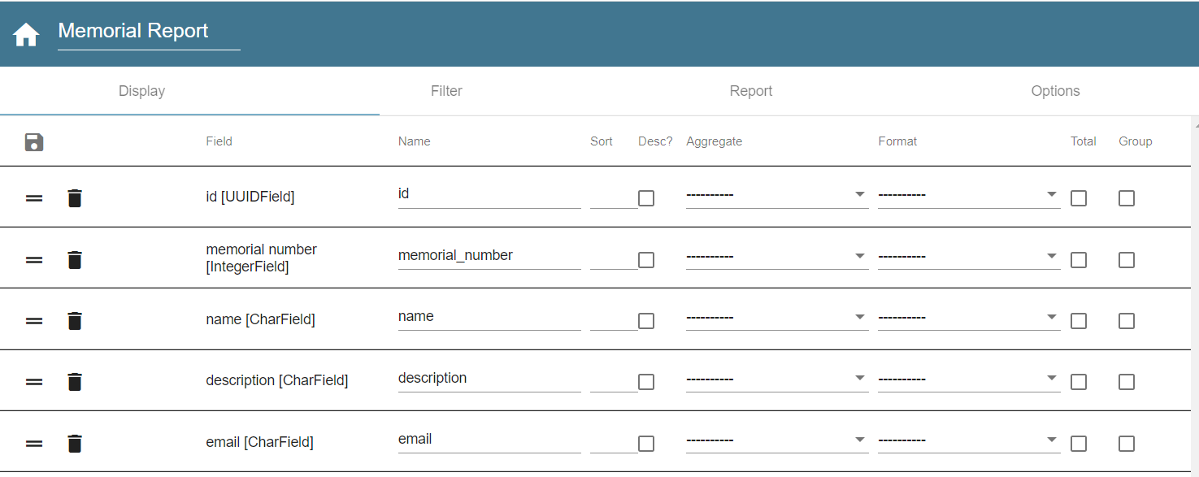

This is what your pre-populated report looks like. You can sort, sort ascending or descending, have aggregate functions or use a pre-made format.

Click the save button in the top left corner. Then select the “Report” tab. Select XSLX or CSV to download your report.

This report will download your selected fields for ALL records. So with this method you can download all fields for all records and some fields for all records.

Say you only want to download a certain amount of records.

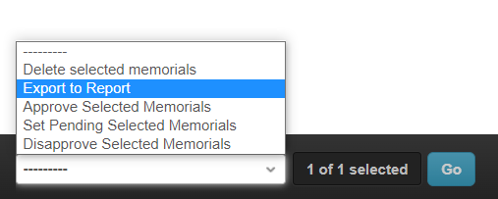

In the admin panel, on the model you want to download, selected the records you want downloaded, then at the bottom left corner, select export to report. Then select your report you want and export.

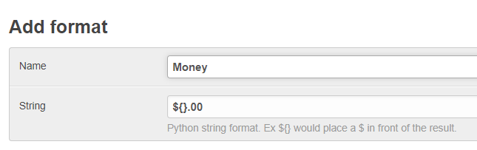

A format is text added onto a field. If the record was “9”. The export would be $9.00 {} is the record you are exporting.